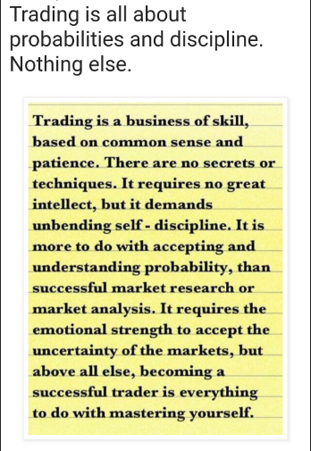

**Identifying Trend from Daily Charts**

At any given point of time NF/BNF will be doing any of below on daily time frame.

* Trending Up -- Recent days are closing above PDH’s
* Trending Down -- Recent days are closing below PDL’s
* Range Bound – Trading in visible range formation

Every day before you prepare for next session, first step is identifying trend on daily charts....Which is our HTF.

You can do this by applying 3 EMA’s on hourly spot chat as well.

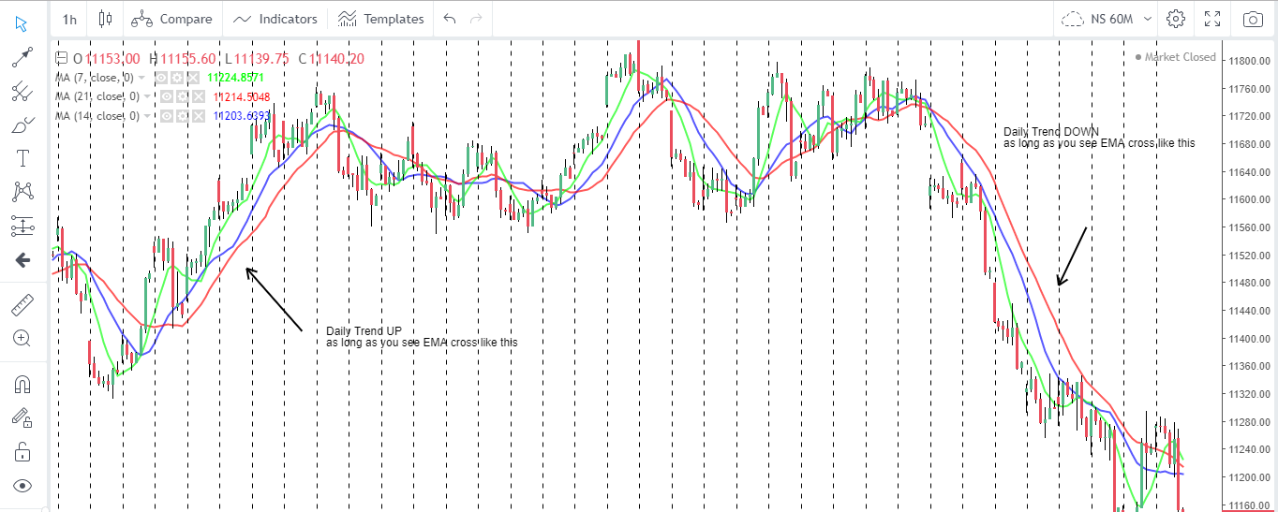

**Defining Market Structure for Next Day**

This is nothing but defining a battle field for next day. I.e. space with in which we expect price to move.

Mark DP’s like PDH, PDL, BRN, PDC, S/R levels from Daily or 60 minute charts.

*Also there is no defining logic involved to identify S/R for me… Which level being attempted to break upside multiple times and failed to do is RESISTANCE & which level being attempted to break downside multiple times and failed to do is SUPPORT.*

Note that during high VIX times, we get many RN/BRN’s… you can consider them only if acted as good S/R in prior day PA & You can get S/R levels from daily candle chart as well... like 3 day low, high etc.

After defining market structure, chart will looks like this.

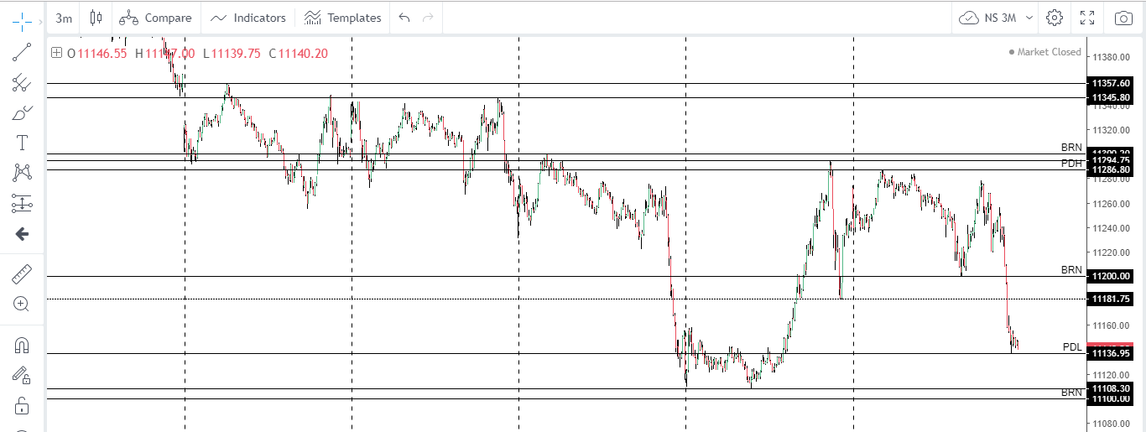

**Pre Market Plan**

So far we have Daily Trend and market structure for next day… with this information we should have a pre-market plan ready.

See below example... Below is my pre market plan for Nifty on 16th May.

Daily Trend is down, so 1st obvious trade I look for is BO/BPB of PDL.

In case gap up or sharp move on upside at opening bell, I watch for rejection at recent resistances (marked on chart with text) to take short in direction of trend.

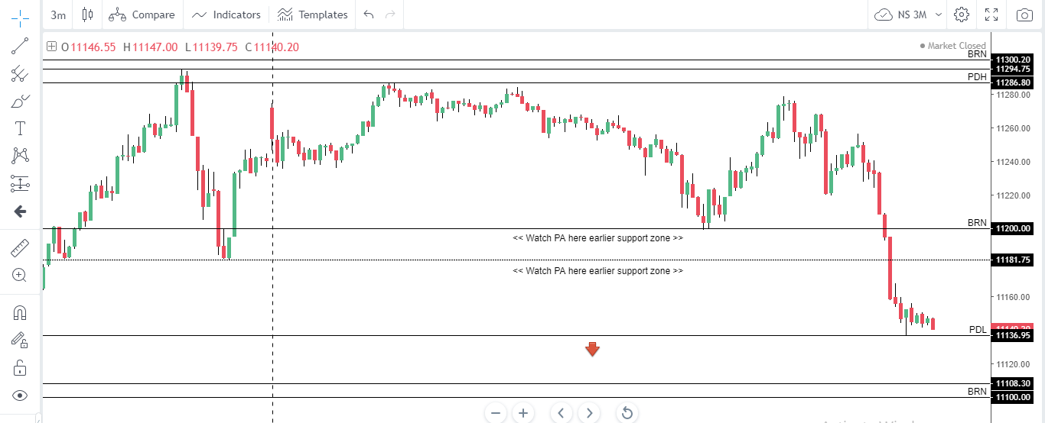

**Understanding PA from market open & preparing for trade setup’s**

This is key part... we should be very attentive at open time as most of momentum moves kick start from open. Let’s continue with above chart example only…. Let’s say, if Nifty opened below PDL... We can look for short as per plan... If gap up, we had plan to look for short at area’s marked.

But if Nifty crossed those resistance levels after making good BOF pattern at PDL, we need to change the bias and look for long opportunities.

As long as nifty making upper ranges continue positive bias, till the time price stay with in PDR, we should be flexible trade ranges. Either buying RL’s or selling RH’s... Depend on context.

Till the time PDH is break and sustain, momentum moves won’t come.

Also keep an eye on daily trend (using EMA’s on hour chart).

Let me summarize few rules to filter high probable trade setups from mediocre.

|  |  |
| --- | --- |
| **Daily Trend** | **Good Setup’s** |
| UP | BO of PDH Long  BPB of PDH Long  BOF of RL Long  BO of RH Long  BPB of RH Long  BOF of PDL Long  BOF of MSP Long  BOF of RL followed by PP setup before breaking RH  Confluence of Range extremes with PDH/PDL produce much better moves |
| DOWN | BO of PDL Short  BPB of PDL Short  BOF of RH Short  BO of RL Short  BPB of RL Short  BOF of PDH Short  BOF of MSP Short  BOF of RH followed by PP setup before breaking RL  Confluence of Range extremes with PDH/PDL produce much better moves |
| Sideways | BOF of RL Long  BOF of RH Short |

**Location and setup to get into Trade**

Below are examples of how we take trades as per different setups.

BO Trade

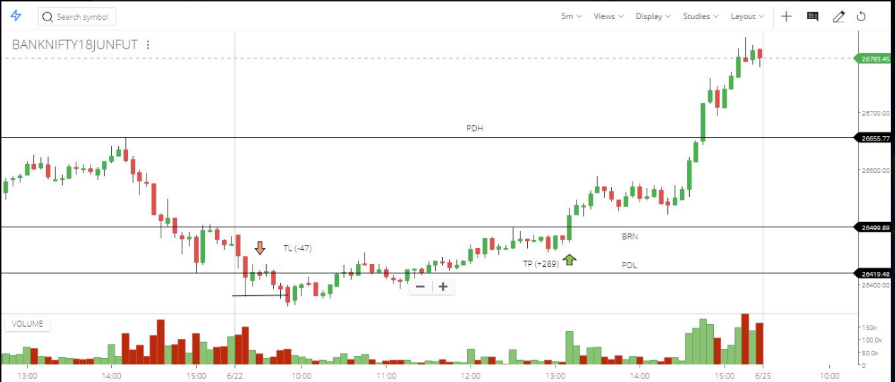

BOF (with volume spike)

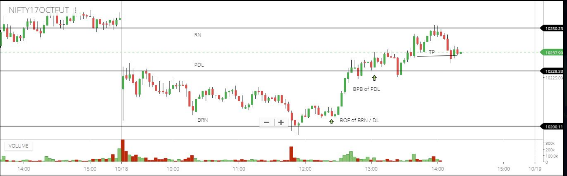

BPB

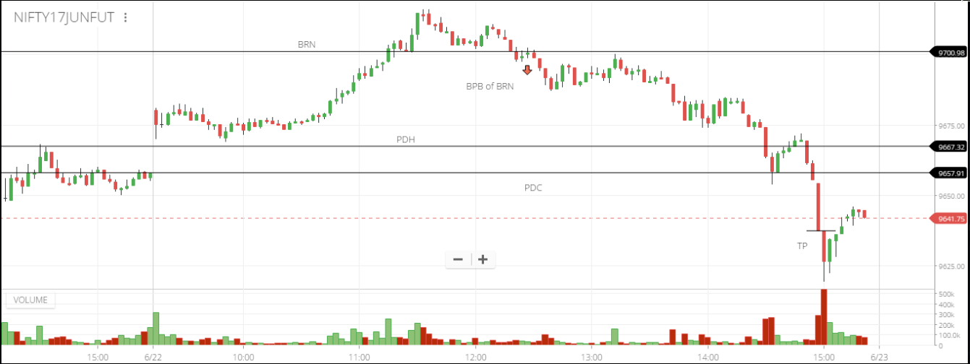

**Read this before initiating trade:**

1. FTA should be at least 15 points away, to allow scratching
2. Check if trapped traders create good order flow; Don't miss BOF of prominent levels
3. Don't risk more than 10-15 points per trade
4. Define exit levels before processing entry itself
5. Never miss Fluids.
6. Check if critical mass (day traders booking profits/market counter gap down below PDL and reverse etc.) provides order flow to your trade.
7. Don’t trade BOF while SAC pattern running/developing.
8. Don’t miss PP trade, if BOF exits at other extreme

**Placing Initial SL**

This is easy part... Your initial SL should be the point where your setup gets invalidated.

Ex: for a BO trade... if price falls down the level from where it break out... That’s where we need to exit.

For BOF trade… high made before price fall back below the resistance line is our idle SL

**Exit Strategy**

I don’t trade with fixed targets… I always prefer to trial my SL behind swing lows made while trade moving in my favor.

Below trade is good example of trialing SL behind swing to catch maximum gain

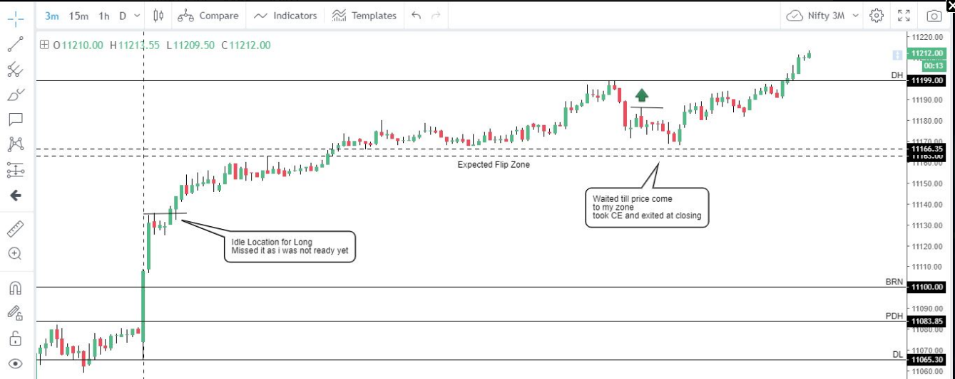

Scratch the trade if price reverse from FTA

Do SAR trades only in case of TRAP entries (Or) you had one profitable trade already

**Choosing Option Strike to Trade**

I Trade in Monthly options. I do add 3 strikes of calls and 3 strikes of puts away from current spot to watch list every day and pick the one which trading near to 100 (+/- 10)

Ex: If NS is opening near to 12100, I do have 12200 call, 12300 call, 12400 call, 12100 put, 12000 put, 11900 put to watch list.

I don’t see Greeks, OI etc. When underlying is moving in favor options do so. Unless index trading in very narrow range (like 20-30 points) and near to expiry, option decay will do some trouble.

But I am perfectly fine as I save lot of costs and having flexibility to enter, re-enter trades with no concern of costs.

Also one advantage of trading ATM strikes, there will be days when you caught trend day and big move happen in favor, option turn ITM & if you do PYRAMIDING as well... That day will make your month.

**Pyramiding Profits**

One of biggest reason for failures in stock market is... not willing to take losses. The only way one sustain in market is cut losses short (we call it SCRATCH)... At the same time it is most important that we try to make more when our trade is moving well and prices trending in our favor.

Instead of averaging losses, average your gains by adding more position after breaking S/R. Here we need to prepare to exit newly added position or total position if our assessment is proven wrong.

See below example

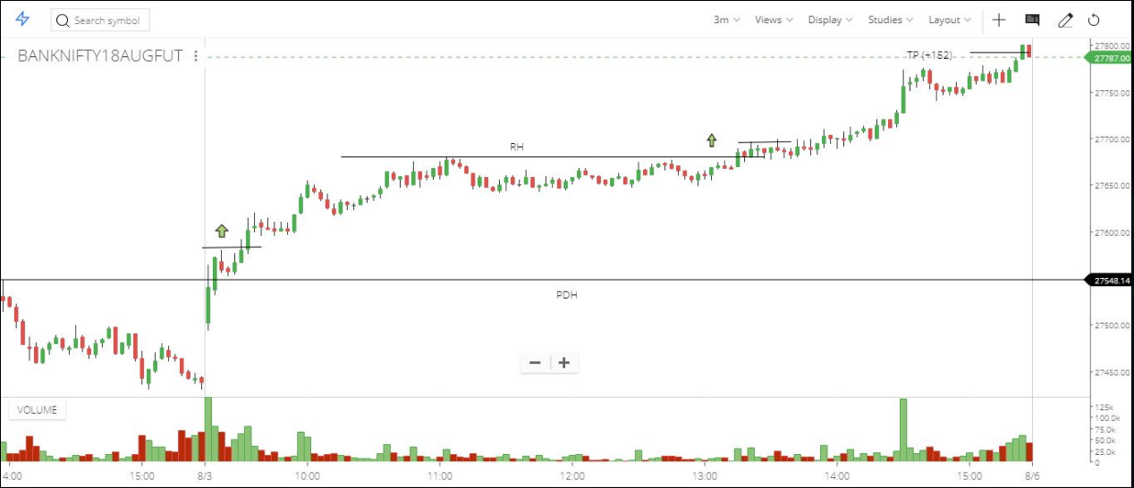

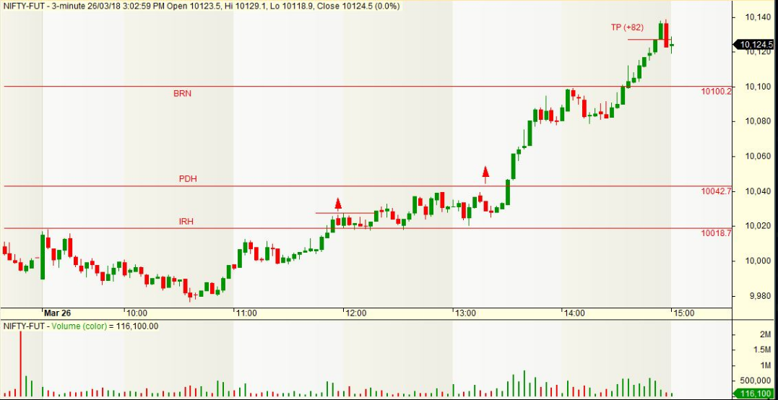

**Effective way to organize your trade plan & thought process**

I suggest to use Microsoft Note to document your analysis done before market open (day trend, pre market view. Levels to watch) and during market open (under market commentary) and trades took with entry, how you moved SL and where you exited.

This is simple technique to have control on your thoughts, instead you listening to games mind plays!

Example:

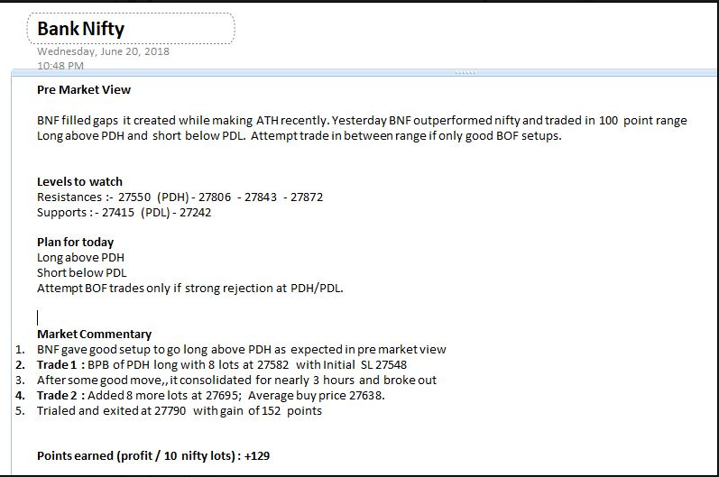

**Money / Risk /Position Management**

I have combined 3 things because they are interdependent.

Since I trade on NF alone. Let’s take it as reference.

* Minimum Capital: To trade one lot of NF, keep one lakh as capital
* Risk per Trade: 0.50 - 1% of capital
* Maximum Initial SL I can afford: 15-20 points in NF
* In range bound and slow type 1 trend days, we can get entries with small SL, one may attempt trade in multiple lots if overall risk is under limit. It completely depends on ongoing PA and quality of setup.
* Consider PYRAMIDING profits on trend days and when you convinced that you can exit extra lot with less damage in case it failed to move as expected.
* Maximum risk per day – 2% of capital

One can use Position sizing excel if trading in equities, stock futures, crude, currency.

**Tackling Losing Streak**

Despite all your skills, rules’, one should be open for series of losses at any given point of time.

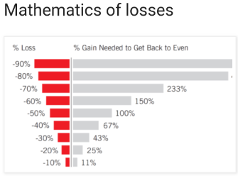

Whenever you see a series of losing trades (say more than 3-4), check how much of capital is eroded. If you lost more than 5%, its time to slow down and do below

1. Reduce risk per trade to 0.5% of capital & continue till you recover earlier loss
2. For any reason, you get another 3-4 loss trades in a row, Take a break for few days and just paper trade.
3. Go to your trade journal, find out where you doing mistakes... it could be you missing good setup’s, you taking pre mature entries, over trading, risking more... Find out Root cause and work in direction of fixing it.

Also keep in mind; you should have MAX DRAWDOWN for capital.

I.e. the maximum limit you let your trading capital to lose.

For me, I set it 25% of capital. I should STOP trading if I hit this & stay sidelines till the time I get confidence to trade again. How individual tackle this kind of situation is depending on his physiology, financial strength, debts etc, don’t want to go in deep here.

**Trade Journal**

I started using a simple excel as trade journal recently. Earlier ‘Only Nifty’ blog we used to log every day trades.

You can go through “Trade Journal” document shared.

Go to each of sheet in excel I shared, you need add your trade entries to make use of it.

All important statistics metric I incorporated.

**When to look at VOLUME in Candlestick charts**

Though I shifted to RENKO, I do have a look at Volume bar in candle charts in below cases for a second confirmation

1. Look if BO happened with good volume, when you trying to take BO/BPB
2. Look if Volume spike happened (trapped traders) when you looking for BOF trades

**Analyzing Trend Strength**

Strength is POOR – if uptrend happening in a channel

Strength is Good – if uptrend happening while respecting flips

Strength is Strong – if uptrend happening with buffer zones

**When to Scratch a Trade**

Consider to scratch trade, if…

1. Price not moving in favor even after 30-45 minutes after entry
2. Entry location not acting as Flip
3. After price moving some in favor and reversing strongly towards entry level
4. When took counter trend trade and if not moving as expected
5. Sometimes i take BPB trades even if DP not touched during PB... if move is not getting extended after entry... I aggressively move SL... If hit, I wait for re-entry near to DP.

**When to trade BO & when to wait for BPB**

I prefer to trade BO over BPB in below cases

1. Prices trending up/down in daily T/F, today have been in tight range. Ideally one should look for BOF of RL long... if missed trade BO of RH
2. When you have FLUID below a tight range – make sure you are trading in intraday trend direction
3. When price opened counter trend above/below PDH/PDL... We can expect good move. Look to trade in direction of counter trend open, instead of waiting for PB. Make sure you not risking more at same time

I prefer to trade BPB over BO in below cases

1. When prices made good move already and breaking good S/R level, wait for BPB entry instead jumping by BO
2. When daily time frame UP, but today gap down happened and prices about to hit PDL or any good support. Wait for BPB entry, because we need to see if trend is changing by sustaining below good support level.

**Miscellaneous Tips**

1. We don’t need to run behind many stocks, NF/BNF are good enough to trade 1-2 trades per day. Have realistic expectations, aim for 100 points on an average per month. This is 7.5% ROI, if you trade 1 lot with 1 Lakh. If possible keep profits added to capital to get compounding effect.
2. We need to be more focused in first 30 minutes generally. Reduce your screen time by placing price alerts (I use trade tiger) … so that you can view charts when it required.
3. Reduce or avoid looking at trade/market views of others in twitter etc. Nobody knows what will happen in next minute. Follow your trade plan.
4. Never trade with borrowed money or money you can’t afford to lose. This will ensure you to handle emotions well.
5. Don’t look at MTM... rather focus on following trade process.

**Trading Journey**

